Analyzing CIA Factbook Data Using SQLite and R

Philipp Pfister

12 Januar 2020

In this self solved project, which makes part of Dataquest.io Data Analyst R Track, I will analyze data from from the CIA World Factbook, a compendium of statistics about all of the countries on Earth. The Factbook contains demographic information like:

* population - The population as of 2015.
* population_growth - The annual population growth rate, as a percentage.
* area - The total land and water area.

The purpose of this project, is to get more familiar with the R packages **RSQLite** and **DBI**, by incorporating SQL into R to clean the data, understand it’s summary statistics and check possible correlations between the variables which may can bring some interesting information. Further, I’ll create visualizations of the data using **ggplot2** and other Tidyverse packages. The included database file can be found [**here**](https://github.com/factbook/factbook.sql/releases).

# Introduction

In the introduction I will:

1. Install and load necessary packages
2. Connecting to Database and verifying included tables
3. Verify for NA values and fix them

#### 1. Installing a loading packages

#install.packages("RSQLite")  
#install.packages("DBI")  
#install.packages("ggcorrplot")  
library(ggcorrplot)  
library(RSQLite)  
library(DBI)  
library(tidyverse)

#### 2. Connecting to database and verifying included tables

conn <- dbConnect(SQLite(), "./factbook.db")  
  
dbListTables(conn) #listing all tables which are in the factbook database

## [1] "facts" "sqlite_sequence"

facts_df <- dbGetQuery(conn, 'SELECT * FROM facts') #taking a look at facts table, passing table to an object for possible later uses  
  
str(facts_df)

## 'data.frame': 240 obs. of 13 variables:  
## $ id : int 1 2 3 4 5 6 7 8 9 10 ...  
## $ code : chr "af" "al" "ag" "an" ...  
## $ name : chr "Afghanistan" "Albania" "Algeria" "Andorra" ...  
## $ area : int 652230 28748 2381741 468 1246700 442 2780400 29743 7741220 83871 ...  
## $ area_land : int 652230 27398 2381741 468 1246700 442 2736690 28203 7682300 82445 ...  
## $ area_water : int 0 1350 0 0 0 0 43710 1540 58920 1426 ...  
## $ population : int 32564342 3029278 39542166 85580 19625353 92436 43431886 3056382 22751014 8665550 ...  
## $ population_growth: num 2.32 0.3 1.84 0.12 2.78 1.24 0.93 0.15 1.07 0.55 ...  
## $ birth_rate : num 38.57 12.92 23.67 8.13 38.78 ...  
## $ death_rate : num 13.89 6.58 4.31 6.96 11.49 ...  
## $ migration_rate : num 1.51 3.3 0.92 0 0.46 2.21 0 5.8 5.65 5.56 ...  
## $ created_at : chr "2015-11-01 13:19:49.461734" "2015-11-01 13:19:54.431082" "2015-11-01 13:19:59.961286" "2015-11-01 13:20:03.659945" ...  
## $ updated_at : chr "2015-11-01 13:19:49.461734" "2015-11-01 13:19:54.431082" "2015-11-01 13:19:59.961286" "2015-11-01 13:20:03.659945" ...

In the database *factbook.db*, we only have one table available, the **facts** table, which contains 13 variables and a total of 261 observations. 4 of them are character and numeric values and 5 are integers.

#### 3. Verify NA values and fixing them

I’ll start by using some of R’s basic functions.

summary(facts_df)

## id code name area   
## Min. : 1.00 Length:240 Length:240 Min. : 0   
## 1st Qu.: 60.75 Class :character Class :character 1st Qu.: 2186   
## Median :120.50 Mode :character Mode :character Median : 73580   
## Mean :121.88 Mean : 587459   
## 3rd Qu.:180.25 3rd Qu.: 414643   
## Max. :255.00 Max. :17098242   
## area_land area_water population population_growth  
## Min. : 0 Min. : 0 Min. :0.000e+00 Min. :0.000   
## 1st Qu.: 2184 1st Qu.: 0 1st Qu.:3.161e+05 1st Qu.:0.430   
## Median : 72980 Median : 470 Median :5.220e+06 Median :1.020   
## Mean : 568379 Mean : 19080 Mean :3.238e+07 Mean :1.195   
## 3rd Qu.: 400560 3rd Qu.: 6472 3rd Qu.:1.835e+07 3rd Qu.:1.847   
## Max. :16377742 Max. :891163 Max. :1.367e+09 Max. :4.020   
## birth_rate death_rate migration_rate created_at   
## Min. : 6.65 Min. : 1.530 Min. : 0.0000 Length:240   
## 1st Qu.:11.97 1st Qu.: 5.978 1st Qu.: 0.4375 Class :character   
## Median :15.99 Median : 7.290 Median : 2.1400 Mode :character   
## Mean :19.11 Mean : 7.756 Mean : 3.6326   
## 3rd Qu.:23.93 3rd Qu.: 9.363 3rd Qu.: 6.1047   
## Max. :45.45 Max. :14.890 Max. :22.3900   
## updated_at   
## Length:240   
## Class :character   
## Mode :character   
##   
##   
##

#counting all NA values existing in the dataframe  
sum(is.na(facts_df))

## [1] 0

It is visible that throughout the whole dataset we have 193 NA values, all represented in the numeric and integer variables. I’ll start to verify the area, area_land and area_water variables, since they are the result of addition *(area = area_land + area_water)*, I may can input NA values in the area variable, by adding available values of the area_land and area_water variable. This may also can be done vice versa.

#### Fixing area, area_land and area_water NA observations

# Query area, area_land and area_water columns which have NA values, to check if NAs can be inputed with new values  
  
dbGetQuery(conn, 'SELECT id, name, area, area_land, area_water, population, population_growth, birth_rate, death_rate, migration_rate  
 FROM facts  
 WHERE area IS NULL OR area_land IS NULL OR area_water IS NULL  
 ')

## [1] id name area   
## [4] area_land area_water population   
## [7] population_growth birth_rate death_rate   
## [10] migration_rate   
## <0 rows> (or 0-length row.names)

**Examing the result we have:**

* 21 total observations where there are at least one missing value in one of the three variables
* 9 observations where all three area variables have missing values. As 8 of them even show NAs in the other variables, these 8 lines will be dropped out of the table
* 5 observations where we have at least two values available and one is missing, here we can by addition or substraction calculate the third value
* 5 observations where we only have the area variable, but land and water are missing, in these cases I will input for the land variable, the same value from the area. The NA water values will be substituted by 0

The alterations will be done directly in the facts table using SQLite syntax.

##### 1. Case: Observations that have NA values in all three area variables. Dropping these 9 cases which present NAs in the area variables, as well as in all other numeric ones which can be seen by the previous output:

dbExecute(conn, '  
 DELETE FROM facts  
 WHERE area IS NULL AND area_land IS NULL AND area_water IS NULL  
 ')

## [1] 0

# Check changes:  
dbGetQuery(conn, 'SELECT id, name, area, area_land, area_water, population, population_growth, birth_rate, death_rate, migration_rate  
 FROM facts  
 WHERE area IS NULL OR area_land IS NULL OR area_water IS NULL  
 ')

## [1] id name area   
## [4] area_land area_water population   
## [7] population_growth birth_rate death_rate   
## [10] migration_rate   
## <0 rows> (or 0-length row.names)

We can see that the nine cases were correctly deleted.

##### 2. Case: From three area variables, two are available and one is NA. Calculating the NA value, by adding or subtracting the two available area variables:

dbExecute(conn, 'UPDATE facts  
 SET area = CASE  
 WHEN area IS NULL AND area_land IS NOT NULL AND area_water IS NOT NULL   
 THEN area_land + area_water  
 ELSE area  
 END,  
 area_land = CASE  
 WHEN area_land IS NULL AND area IS NOT NULL AND area_water IS NOT NULL  
 THEN area - area_water  
 ELSE area_land  
 END,  
 area_water = CASE  
 WHEN area_water IS NULL AND area IS NOT NULL AND area_land IS NOT NULL  
 THEN area - area_land  
 ELSE area_water  
 END  
 ')

## [1] 240

dbGetQuery(conn, 'SELECT id, name, area, area_land, area_water, population, population_growth, birth_rate, death_rate, migration_rate  
 FROM facts  
 WHERE area IS NULL OR area_land IS NULL OR area_water IS NULL  
 ')

## [1] id name area   
## [4] area_land area_water population   
## [7] population_growth birth_rate death_rate   
## [10] migration_rate   
## <0 rows> (or 0-length row.names)

Checking again, we can see that the cases which had in the area variables one NA value and two non NA values, are now not listed anymore. Next we will take care of our third and last case regarding the area variables, which are cases where we only have the area variable, but land and water ones are missing, in these cases I will input for the land variable, the same value from the area and for the water variable I will input 0.

##### 3. Case: area variable available, but land and water are NA values. Area_land will receive the same value as area and area_water the value 0 instead of NA.

dbExecute(conn, '  
 UPDATE facts  
 SET area_land = CASE  
 WHEN area_land IS NULL AND area_water IS NULL AND area IS NOT NULL THEN  
 area  
 ELSE area_land  
 END,  
 area_water = CASE  
 WHEN area_water IS NULL THEN  
 0  
 ELSE area_water  
 END  
 ')

## [1] 240

facts_df2 <- dbGetQuery(conn, 'SELECT * FROM facts') # new facts table with deleted NA values for area variables  
  
summary(facts_df2)

## id code name area   
## Min. : 1.00 Length:240 Length:240 Min. : 0   
## 1st Qu.: 60.75 Class :character Class :character 1st Qu.: 2186   
## Median :120.50 Mode :character Mode :character Median : 73580   
## Mean :121.88 Mean : 587459   
## 3rd Qu.:180.25 3rd Qu.: 414643   
## Max. :255.00 Max. :17098242   
## area_land area_water population population_growth  
## Min. : 0 Min. : 0 Min. :0.000e+00 Min. :0.000   
## 1st Qu.: 2184 1st Qu.: 0 1st Qu.:3.161e+05 1st Qu.:0.430   
## Median : 72980 Median : 470 Median :5.220e+06 Median :1.020   
## Mean : 568379 Mean : 19080 Mean :3.238e+07 Mean :1.195   
## 3rd Qu.: 400560 3rd Qu.: 6472 3rd Qu.:1.835e+07 3rd Qu.:1.847   
## Max. :16377742 Max. :891163 Max. :1.367e+09 Max. :4.020   
## birth_rate death_rate migration_rate created_at   
## Min. : 6.65 Min. : 1.530 Min. : 0.0000 Length:240   
## 1st Qu.:11.97 1st Qu.: 5.978 1st Qu.: 0.4375 Class :character   
## Median :15.99 Median : 7.290 Median : 2.1400 Mode :character   
## Mean :19.11 Mean : 7.756 Mean : 3.6326   
## 3rd Qu.:23.93 3rd Qu.: 9.363 3rd Qu.: 6.1047   
## Max. :45.45 Max. :14.890 Max. :22.3900   
## updated_at   
## Length:240   
## Class :character   
## Mode :character   
##   
##   
##

Looking at the summary statement above, it is visible that the area, area_land and area_water variables have now 1 or no NA observations. Next, I’ll verify and try to fix the NA values located in the population, population_growth, birth_rate, death_rate and migration_rate variables.

I’ll start by displaying all observations which have at least one NA value in these variables.

dbGetQuery(conn, '  
 SELECT *  
 FROM facts  
 WHERE population IS NULL OR   
 population_growth IS NULL OR   
 birth_rate IS NULL OR  
 death_rate IS NULL OR  
 migration_rate IS NULL  
 ')

## [1] id code name   
## [4] area area_land area_water   
## [7] population population_growth birth_rate   
## [10] death_rate migration_rate created_at   
## [13] updated_at   
## <0 rows> (or 0-length row.names)

The query returned 29 observations where at least one of their variables have an NA value. Possible options of what to do with these NA values are to use each variables respective:

* average value or
* look up in the internet values for each observation

Starting with the population variable, we have 12 observations with NA values. For each one I will look up their population size using following sources:

* [CIA World Factbook](https://www.cia.gov/library/publications/resources/the-world-factbook/)
* [Worldbank](https://data.worldbank.org/country)

#### Fixing population NA observations

From the 12 observations, I was able to find the population of only one, [Paracel Islands](https://www.cia.gov/library/publications/the-world-factbook/geos/pf.html) (1,440 (2014 est.)). All others are territories without inhabitants. Further, all these 12 observations (including Paracel Islands) also have NA values in the other integer variables. So, after this short research I’ll update the values of the population variable, and even if Paracel Island has a value for population, this one as well as the eleven other ones will be deleted.

##### Case: Observations with NA values in the population variable as well NA values in the other integer variables. All will be deleted:

#Updating Paracel Island value  
dbExecute(conn, '  
 DELETE   
 FROM facts  
 WHERE id IN (198, 201, 202, 208, 222, 223, 228, 240, 244, 248, 252, 253)  
 ')

## [1] 0

# Checking:  
dbGetQuery(conn, '  
 SELECT COUNT(id) FROM facts  
 WHERE population IS NULL  
 ')

## COUNT(id)  
## 1 0

Querying observations which counts observations with NA values in the variable population, we receive zero observations. So all NA values in the population variable are deleted.

Next, I will take a look at the other variables like, population_growth, birth_rate, death_rate and migration_rate. Here I will try to input estimated values using the average, of similar observations, for example from observations with similar population and area size.

##### Case: Observations with NA values in the population_growth variable:

# Visualizing observations which still got NA values  
dbGetQuery(conn, '  
 SELECT *  
 FROM facts  
 WHERE population_growth IS NULL OR birth_rate IS NULL OR death_rate IS NULL OR migration_rate IS NULL  
 ')

## [1] id code name   
## [4] area area_land area_water   
## [7] population population_growth birth_rate   
## [10] death_rate migration_rate created_at   
## [13] updated_at   
## <0 rows> (or 0-length row.names)

# Display total average population_growth and the population_growth average from countries which have a population size equal as the MAX and MIN from the observations with missing population_growth value  
dbGetQuery(conn, '  
 SELECT AVG(population_growth) AS total_pop_growth_avg, (SELECT AVG(population_growth)  
 FROM facts  
 WHERE population BETWEEN 0 AND 1870981 AND   
 population_growth IS NOT NULL AND   
 area BETWEEN 0 AND 10887  
 ) AS case_pop_growth_avg  
 FROM facts  
 ')

## total_pop_growth_avg case_pop_growth_avg  
## 1 1.194742 0.877619

Above we can see that the average population growth, including all data of the datset is 1.201489. Also, the average population growth of countries which have an area and population size similar to the countries with NA values in population_growth, is 0.877619. I will use this number to input into the observations with missing population_growth variable.

dbExecute(conn, '  
 UPDATE facts  
 SET population_growth = CASE  
 WHEN population_growth IS NULL   
 THEN  
 (SELECT AVG(population_growth)  
 FROM facts  
 WHERE population BETWEEN 0 AND 1870981 AND   
 population_growth IS NOT NULL AND   
 area BETWEEN 0 AND 10887)  
 ELSE population_growth  
 END  
 ')

## [1] 240

# Count how many observations do have NA values in population_growth  
dbGetQuery(conn, '  
 SELECT COUNT(id)  
 FROM facts  
 WHERE population_growth IS NULL  
 ')

## COUNT(id)  
## 1 0

By querying all observations with NA values in population_growth, we now see that there are no NA values anymore. Next we will do the same approach for the last three variables, birth_rate, death_rate and migration_rate.

##### Case: Observations with NA values in the birth, death and migration_rate variable:

dbExecute(conn, '  
 UPDATE facts  
 SET birth_rate = CASE  
 WHEN birth_rate IS NULL   
 THEN  
 (SELECT AVG(birth_rate)  
 FROM facts  
 WHERE population BETWEEN 0 AND 1870981 AND   
 birth_rate IS NOT NULL AND   
 area BETWEEN 0 AND 10887)  
 ELSE birth_rate  
 END,  
 death_rate = CASE  
 WHEN death_rate IS NULL   
 THEN  
 (SELECT AVG(death_rate)  
 FROM facts  
 WHERE population BETWEEN 0 AND 1870981 AND   
 death_rate IS NOT NULL AND   
 area BETWEEN 0 AND 10887)  
 ELSE death_rate  
 END,  
 migration_rate = CASE  
 WHEN migration_rate IS NULL   
 THEN  
 (SELECT AVG(migration_rate)  
 FROM facts  
 WHERE population BETWEEN 0 AND 1870981 AND   
 migration_rate IS NOT NULL AND   
 area BETWEEN 0 AND 10887)  
 ELSE migration_rate  
 END  
 ')

## [1] 240

# save cleaned table in a R dataframe  
facts_cleaned <- dbGetQuery(conn, 'SELECT * FROM facts')  
  
# count number of NA observations in cleaned dataframe  
sum(is.na(facts_cleaned))

## [1] 0

summary(facts_cleaned)

## id code name area   
## Min. : 1.00 Length:240 Length:240 Min. : 0   
## 1st Qu.: 60.75 Class :character Class :character 1st Qu.: 2186   
## Median :120.50 Mode :character Mode :character Median : 73580   
## Mean :121.88 Mean : 587459   
## 3rd Qu.:180.25 3rd Qu.: 414643   
## Max. :255.00 Max. :17098242   
## area_land area_water population population_growth  
## Min. : 0 Min. : 0 Min. :0.000e+00 Min. :0.000   
## 1st Qu.: 2184 1st Qu.: 0 1st Qu.:3.161e+05 1st Qu.:0.430   
## Median : 72980 Median : 470 Median :5.220e+06 Median :1.020   
## Mean : 568379 Mean : 19080 Mean :3.238e+07 Mean :1.195   
## 3rd Qu.: 400560 3rd Qu.: 6472 3rd Qu.:1.835e+07 3rd Qu.:1.847   
## Max. :16377742 Max. :891163 Max. :1.367e+09 Max. :4.020   
## birth_rate death_rate migration_rate created_at   
## Min. : 6.65 Min. : 1.530 Min. : 0.0000 Length:240   
## 1st Qu.:11.97 1st Qu.: 5.978 1st Qu.: 0.4375 Class :character   
## Median :15.99 Median : 7.290 Median : 2.1400 Mode :character   
## Mean :19.11 Mean : 7.756 Mean : 3.6326   
## 3rd Qu.:23.93 3rd Qu.: 9.363 3rd Qu.: 6.1047   
## Max. :45.45 Max. :14.890 Max. :22.3900   
## updated_at   
## Length:240   
## Class :character   
## Mode :character   
##   
##   
##

# check observation which still has one NA value  
facts_cleaned %>%  
 filter(is.na(area))

## [1] id code name   
## [4] area area_land area_water   
## [7] population population_growth birth_rate   
## [10] death_rate migration_rate created_at   
## [13] updated_at   
## <0 rows> (or 0-length row.names)

As seen above, from 193 NA values at the beginning, we were able to reduce all missing values to only one. Further, instead of deleting all NA values right away, which wouldn’t be a good decision, since the whole dataset just have a small number of observations (261), it was considered more valuable to use the average values of each variable.

Next, we will get to the main part where we will:

* look at summary statistics
* check correlations between the variables

# Main Part

Here I’ll calculate some summary statistics and check for any outlier countries. I’ll do this by writing a single query that returns the:

* minimum population
* maximum population
* minimum population growth
* maximum population growth

dbGetQuery(conn, 'SELECT  
 MIN(population), MAX(population), MIN(population_growth), MAX(population_growth)  
 FROM facts  
 ')

## MIN(population) MAX(population) MIN(population_growth)  
## 1 0 1367485388 0  
## MAX(population_growth)  
## 1 4.02

var(facts_cleaned$population)

## [1] 1.650137e+16

Looking at the results it seems that:

* there’s a country with a population of 0
* there’s a country with a population of 1367485388 or around 1.36 billion people!

Following I’ll include in the query above, the country name variable and a *WHERE* condition to select the cases we just asked for.

dbGetQuery(conn, 'SELECT  
 name, population, population_growth  
 FROM facts  
 WHERE population = (SELECT MIN(population) FROM facts) OR  
 population = (SELECT MAX(population) FROM facts) OR  
 population_growth = (SELECT MIN(population_growth) FROM facts) OR  
 population_growth = (SELECT MAX(population_growth) FROM facts)  
 ')

## name population population_growth  
## 1 China 1367485388 0.450000  
## 2 South Sudan 12042910 4.020000  
## 3 Holy See (Vatican City) 842 0.000000  
## 4 Cocos (Keeling) Islands 596 0.000000  
## 5 Greenland 57733 0.000000  
## 6 Pitcairn Islands 48 0.000000  
## 7 Antarctica 0 0.877619

Above we can identify the two cases with extreme low and high population value, these are, the 0 population case, which is Antartica as well as an entry of Chinas total population. Since Antartica is not a normal country with regular inhabitants and the only not permanent inhabitants are scientist , I’ll exclude it in a revised query, as well as save the result in a new object.

facts_cleaned <- dbGetQuery(conn, "SELECT *  
 FROM facts   
 WHERE (population != (SELECT MIN(population) FROM facts))  
 ")  
  
df_clean2 <- dbGetQuery(conn, "SELECT   
 name, population, population_growth, birth_rate, death_rate   
 FROM facts   
 WHERE (population != (SELECT MIN(population) FROM facts))  
 ")  
  
head(df_clean2)

## name population population_growth birth_rate death_rate  
## 1 Afghanistan 32564342 2.32 38.57 13.89  
## 2 Albania 3029278 0.30 12.92 6.58  
## 3 Algeria 39542166 1.84 23.67 4.31  
## 4 Andorra 85580 0.12 8.13 6.96  
## 5 Angola 19625353 2.78 38.78 11.49  
## 6 Antigua and Barbuda 92436 1.24 15.85 5.69

Now I’ll create histograms for each of the columns. Using just the non-outlier rows, generating histograms for the following columns:

* population
* population_growth
* birth_rate
* death_rate

# z = column vector  
histog <- function (z) {  
 ggplot(data = df_clean2) +   
 aes_string(x = z) +  
 geom_histogram(aes(y =..density..),   
 col="black",  
 fill="blue",   
 alpha= 0.7) +  
 geom_density(col=2,  
 fill = "red",  
 alpha = 0.15) + # adding density line  
 ggtitle(paste("Distribution of", z, "variable")) +  
 geom_vline(aes(xintercept = mean(z)),col='red')  
}  
  
  
# Create the vector z:  
z = names(df_clean2[,2:5]) # from the dataframe df2 selecting the columns: population  
  
# Using map function from purrr package to run the function with the vector z:  
map(z, histog)

## [[1]]

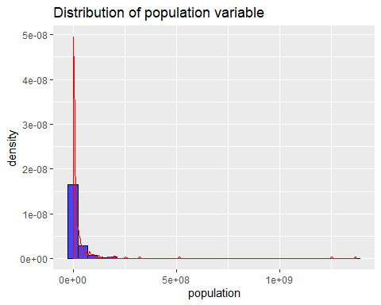

##   
## [[2]]

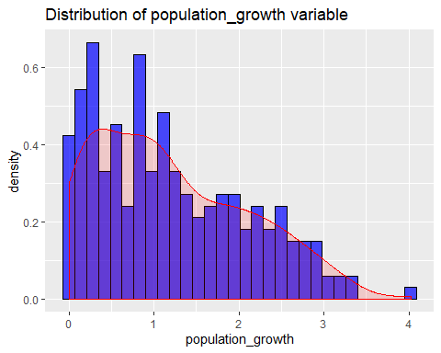

##   
## [[3]]

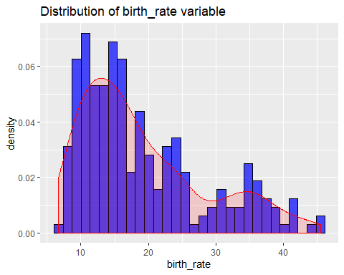

##   
## [[4]]

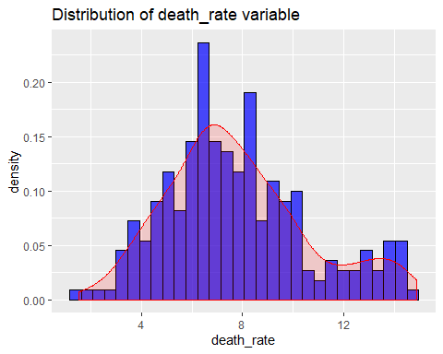

It is visable that none of the variables have a normal, bell shaped distribution (so, not suitable for linear regression models), all of them, except the *death_rate* variable, are right skewed. Further we have extreme outliers in the population variable, which should be caused by countries like China and India. But since the population histogram is very skewed and difficult to read, I’ll redo it, scaling the x-axis properly as well as trying to use a different number of bins.

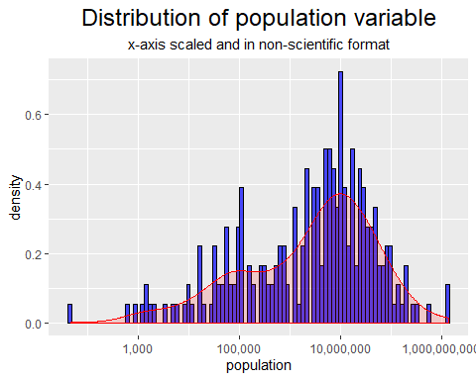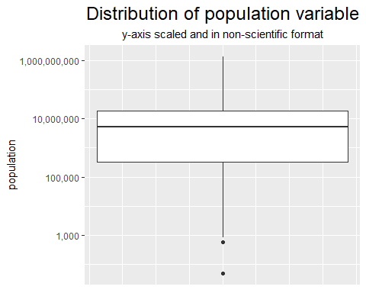

# summary statistics of population variable  
format(summary(df_clean2$population), scientific = FALSE)

## Min. 1st Qu. Median Mean 3rd Qu.   
## " 48" " 328258" " 5231422" " 32512449" " 18544404"   
## Max.   
## "1367485388"

After adjusting the population histogram and adding a boxplot graphic, it is clear that around 50% of the countries found in the fact table have a population of more than 100,000 to a bit more than 10,000,000 inhabitants. Using R’s basic summary function shows that the median value is around *5.23 million* people.

### Check possible correlations by displaying a heatmap

I’ll will check if between the variables: area, area_land, area_water, population, population_growth, birth_rate, death_rate and migration_rate exists some kind of correlation, using defaults pearson correlation.

# creating dataframe that includes only necessary variables:  
facts_cleaned2 <- facts_cleaned[, 4:11]  
  
# create a correlation matrix:  
fact_cor <- cor(facts_cleaned2)  
  
ggcorrplot(fact_cor, type = "lower", lab = TRUE)

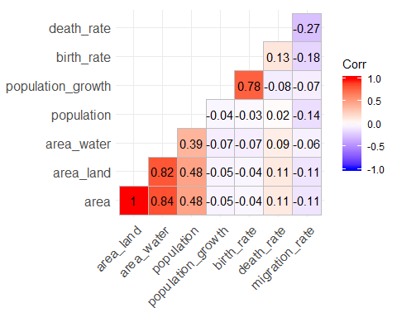

As it can be seen from the correlation graph above, we have medium to strong correlations between the area variables, which makes sense, further we have a strong correlation between the population_growth and birth_rate variables, which is logical, since a higher birth_rate results normally in more people in the country and since this, a growing population. Besides of this we have a very weak negative correlation (-0.27) between death_rate and migration_rate. This is a correlation I expected to be positive and maybe even stronger. Since I thought that more people would leave a country and migrate to another if the death_rate of its original country would be high.

# Conclusion and Disconnecting of database

So, this projects aim was to increase familarity into the SQL package **RSQLite**, using its functions to accomplish basic summary statistics as well as to clean and fix the data set, here especially the NA values which we found at the beginning. Further, by using **ggplot2** as well as **ggcorrplot** our aim was to better understand the data, how it is distributed and how each variable is correlated to each other, to find out some interesting correlations.

Unfortunately, the available data was limited with only 261 observations, not containing year data to verify the development of some variables over time and for specific countries, as well it did not contain social or economical information, to dig in deeper.

# Clear results and disconnect from database  
dbDisconnect(conn)